FULL STACK WEB DEVELOPMENT
LABORATORY RECORD — EXPERIMENT 04

1. BASIC INFORMATION
Experiment No. | 04
Date | 14/08/2026
Title | Student Profile Manager using JavaScript Class and DOM
Application | Student Profile Manager
Course Outcome | CO1

2. AIM
To develop a Student Profile Manager using a JavaScript class, objects, DOM manipulation, and event handling to dynamically display student details entered by the user.

3. OBJECTIVES
- Create a JavaScript class for student information.
- Create a Student object using the class constructor.
- Read student details from HTML input fields.
- Handle the Display Profile button using an event listener.
- Create HTML elements dynamically using JavaScript.
- Display the generated student profile on the webpage.

4. THEORY
A JavaScript class is a blueprint used to create objects with related properties and methods. The Student class represents student information such as name, roll number, department, and CGPA.
The DOM allows JavaScript to select, create, modify, and add HTML elements dynamically. Event handling is used to execute the profile-generation code when the button is clicked.

5. SOFTWARE / APPARATUS USED
- Computer / Laptop
- Windows 10 / 11
- Visual Studio Code
- Google Chrome / Microsoft Edge
- HTML5, CSS3 and JavaScript

6. ALGORITHM / PROCEDURE
- Create input fields for Name, Roll Number, Department and CGPA.
- Create a Display Profile button and profile container.
- Define the Student class with the required properties.
- Read the input values using DOM methods.
- Create a Student object using the class constructor.
- Create profile elements dynamically.
- Add the generated elements to the profile container.
- Open the webpage and verify the generated student profile.

7. SOURCE CODE

HTML — index.html
<!DOCTYPE html>
<html>
<head>
<title>Student Profile Manager</title>
<link rel="stylesheet" href="style.css">
</head>
<body>
<div class="container">
<h1>Student Profile Manager</h1>
<input type="text" id="name" placeholder="Name">
<input type="text" id="rollNo" placeholder="Roll Number">
<input type="text" id="department" placeholder="Department">
<input type="number" id="cgpa" step="0.01" placeholder="CGPA">
<button id="displayBtn">Display Profile</button>
<div id="profile"></div>
</div>
<script src="app.js"></script>
</body>
</html>

JavaScript — app.js
class Student {
constructor(name, rollNo, department, cgpa) {
this.name = name;
this.rollNo = rollNo;
this.department = department;
this.cgpa = cgpa;
}
}
document.getElementById("displayBtn").addEventListener("click", function () {
const student = new Student(
document.getElementById("name").value,
document.getElementById("rollNo").value,
document.getElementById("department").value,
document.getElementById("cgpa").value
);
const profile = document.getElementById("profile");
profile.innerHTML = "";
const card = document.createElement("div");
card.className = "student-card";
const heading = document.createElement("h2");
heading.textContent = "Student Profile";
const name = document.createElement("p");
name.innerHTML = "<strong>Name:</strong> " + student.name;
const roll = document.createElement("p");
roll.innerHTML = "<strong>Roll No:</strong> " + student.rollNo;
const dept = document.createElement("p");
dept.innerHTML = "<strong>Department:</strong> " + student.department;
const cgpa = document.createElement("p");
cgpa.innerHTML = "<strong>CGPA:</strong> " + student.cgpa;
card.append(heading, name, roll, dept, cgpa);
profile.appendChild(card);
});

CSS — style.css
body {
font-family: Arial, sans-serif;
background: #f2f2f2;
padding: 30px;
}
.container {
max-width: 500px;
margin: auto;
background: white;
padding: 30px;
border-radius: 12px;
}
input {
width: 100%;
box-sizing: border-box;
padding: 10px;
margin: 8px 0;
}
button {
width: 100%;
padding: 12px;
margin-top: 15px;
cursor: pointer;
}
.student-card {
margin-top: 25px;
padding: 20px;
border: 1px solid #ccc;
border-radius: 10px;
}

8. CODE EXPLANATION
Code / Concept | Purpose
class Student | Blueprint for student objects.
constructor() | Initializes student properties.
new Student() | Creates a Student object.
getElementById() | Selects HTML elements.
addEventListener() | Handles the button click.
createElement() | Creates HTML elements dynamically.
textContent | Sets text of an element.
appendChild() | Adds an element to the DOM.

9. TEST CASES
Test Case | Input | Expected Result | Status
TC-01 | Valid student details | Student profile is displayed | Pass
TC-02 | Click Display Profile | Profile card is generated dynamically | Pass
TC-03 | Change student details | Updated details are displayed | Pass

10. EXECUTION STEPS
- Open the student-profile-manager folder.
- Open index.html in a browser.
- Enter student name, roll number, department and CGPA.
- Click Display Profile.
- Observe the dynamically generated profile.
- Change a value and click the button again to verify updating.

11. OUTPUT
The following is the actual captured browser output of the Student Profile Manager.
Figure 1: Student Profile Manager — Actual Output
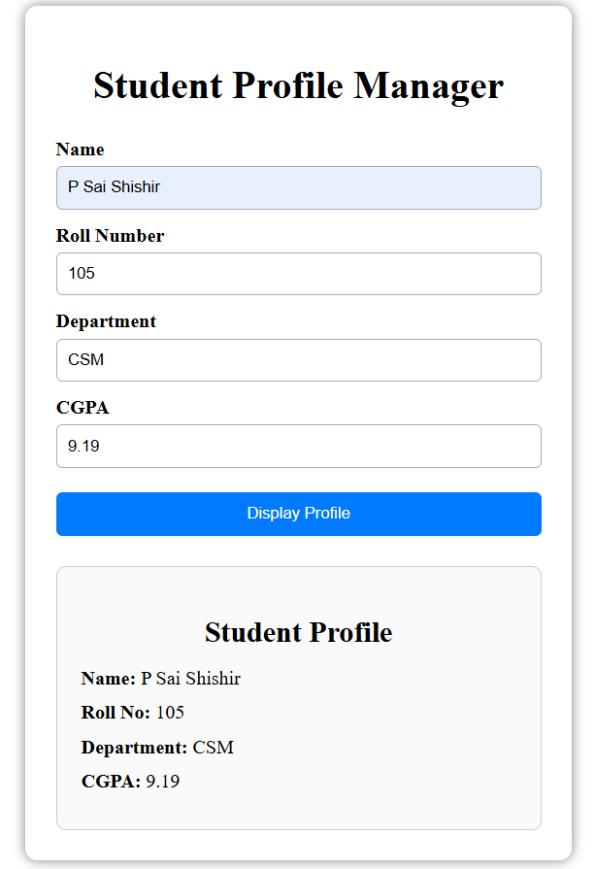

12. RESULT ANALYSIS
The entered student details were successfully used to create a Student object. JavaScript then created the profile elements dynamically and inserted them into the webpage.

13. RESULT / CONCLUSION
The Student Profile Manager was successfully implemented using JavaScript classes, objects, DOM manipulation, and event handling.

14. PRECAUTIONS
- Match HTML IDs with JavaScript IDs.
- Enter valid student details.
- Ensure JavaScript and CSS files are linked correctly.
- Save the files before refreshing the webpage.
- Check the browser console if the profile is not generated.

15. VIVA-VOCE QUESTIONS
1. What is a class?
A class is a blueprint used to create objects.
2. What is an object?
An object is an instance created from a class.
3. What is a constructor?
It initializes object properties when the object is created.
4. What is DOM manipulation?
It is changing or creating webpage elements using JavaScript.
5. What does createElement() do?
It creates a new HTML element dynamically.

